**Population score includes**

* **Population**
* **Median age**

Population: applied (value-10_000_000)/10_000_000 to the population, to set 10 mill to the maximum score and the farther away from 10 mill the population is, the lower the score gets.

Then applied ln to prison mike values (because of big spread) and then used formula: (value-min)/(max-min) to get a score between 0 and 1. 1 being the country with 10 mill inhabitants. 0 being china with largest difference to 10 mill.

Median age: use formula: (value-min)/(max-min)

Take the average value (pop+age)/2

Then in the final step: apply weighting *0.4

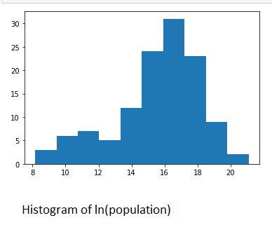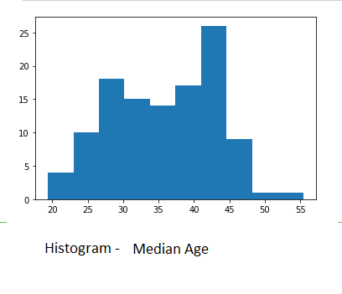

**Efficiency score includes**

* **GDP per capita**
* **LPI**

GDP: applied ln to population and then use formula: (value-min)/(max-min)

LPI: use formula: (value-min)/(max-min)

Take the average value (gdp+lpi)/2

Then in the final step: apply weighting *0.25

